|  |  |  |  |  |  |  |  |  |  |  |  |  |
| --- | --- | --- | --- | --- | --- | --- | --- | --- | --- | --- | --- | --- |
| **P** | **S** | **Y** | **C** | **H** | **O** | **L** | **O** | **G** | **I** | **C** | **A** | **L** |
|  |  |  |  | **C** | **O** | **D** | **I** | **N** | **G** |  |  |  |
|  |  |  |  |  |  | **O** | **F** |  |  |  |  |  |
|  |  |  |  | **V** | **E** | **R** | **B** | **A** | **L** |  |  |  |
| **C** | **O** | **M** | **M** | **U** | **N** | **I** | **C** | **A** | **T** | **I** | **O** | **N** |

Edition 3

Merle L. Canfield & Joy E. Canfield

Copyright © 2014 by Merle L. Canfield

4504 N Valentine Ave Apt 125

Fresno, CA 93711

All rights reserved

No part of this document may be reproduced

in any way without the prior agreement and

written permission of the author.

This is an instruction manual for rating and analyzing verbal communication. As of this writing, two methods are used to code verbal communication. The first method codes utterances on the dimensions of Contracts, Cognitions, Feelings, Performance, Rewards, Persons, and Psychosocial Settings. The second method uses the ratings from the first method and assesses the content of utterances. Utterances of dialogue among speakers are analyzed by the use of crosslagged correlations. The crosslagged correlations form matrices that can be compared.

These methods have developed in stages since 1985. Chapter __ describes the developmental process of the ratings of Contracts, Cognitions, and Feelings. Chapter __ describes the developments of Performance, Rewards, Persons and Settings.

Chapter 1

**Getting Started**

Merle Canfield

*The programs are online at: psychcoder7.com*

Three different types of text are presented with methods of input to the program (see below). The program produces some kinds of analysis and/or prepares data to be analyzed manually or various statistical software packages. The original intent was to analyze psychotherapy sessions with a therapist and a client. The original paper was the result of that. In the paper a major purpose of the analysis was to determine the reaction (or response) of the therapist to the client. That is if the client made a statement then what was the reaction (or response ) of the therapist. And vice versa what was the reaction (response) of the client to the therapist. Consequently, the analysis required the “turn taking” of the client and therapist.

Example 1:

Therapist: Good morning. How are you today?

Client: Pretty good except of some weird dreams and conflicts with Bob.

Therapist: Which would you like to talk about first?

Client: I guess my conflicts.

This dialog is ready to be analyzed (coded) by Psychcoder7.com as it is: (1) the therapist and client take turns speaking, (2) the speaker identification (therapist; client) is followed by a colon (:), (3) the client identifier is “client:” and not the client’s name like “Mary”, (4) there are no other colons in the text, (5) there are not “duplicate” identifiers within the text (for example, “client” followed by “client.” However, when the dialog becomes pages in length (hundreds of utterances) it is almost impossible to find all duplicates and consequently the computer program will eliminate them.

If there are more than 2 speakers or the research does not plan to perform contingency analysis on the data then speakers can be identified by simply by adding a colon to their name. Please note later when running the psychcoder7.com program a special box must be selected (clicked).

Example 2:

Fred: Who will be attending the gathering tomorrow?

Doris: Can’t go I have to work. I am so disappointed I have been planning on it for weeks.

Helen: I am going.

Juan: Yep.

Fred: Anybody else. It will be a great program. Demonstrations and all.

Doris: I thought so. I just may tell my boss that I have to go to the gathering.

In this next example the researcher my want to code a book or a paper with no comparisons.

Example 3:

Sally entered the subway slowly. Exhausted after a long day of one meeting after another where she was expected to explain the changes that the company was making. Nobody liked the changes. Who would?

This text could be entered as it is and there would be a single number for each rating category. However, it might be useful to treat each sentence as a response and in that case the all punctuation should be globally converted to space colon before analysis like the following. Notice that the replacements of the sentence ending punctuation is retained with a space and then the colon. The punctuation is retained because the program sometimes uses it especially the “?” as part of the coding process. This can be done by using a “global replace” command in processing programs such as MS Word.

The commuter entered the subway slowly . : Exhausted after a long day of one meeting after another where she was expected to explain the changes that the company was making . : Nobody liked the changes . : Who would ? :

In the next example it is assumed that two (or more) books, speeches, news articles, songs, or etc are to be compared by the researcher. It is similar to Example 2 except there is more than one book or etc.

Example 4:

xsession-1

The commuter entered the subway slowly . : Exhausted after a long day of one meeting after another where she was expected to explain the changes that the company was making . : Nobody liked the changes . : Who would ?

xsession-2

The solder squinted in the distance . : Was there movement across the clearing . : He couldn’t be sure . : Then he saw a reflection off of something . : In these parts that could only be something man made . : Who could it be ?

Notice that the sentence ending periods (.) have been replaced by colons in both sets but also each set begins with xsession a dash and a number. The xsession results in each (now a unit record of data) containing the number as indicatged by the xsession number. The two above sessions could be compared with an ANOVA or t-test (or any other kind of analysis). It is now data.

The xsession function can be used with any kind of transcript including the therepay session above.

This next section presents examples of the procedure for running the program. The following is the web page along with the choices.

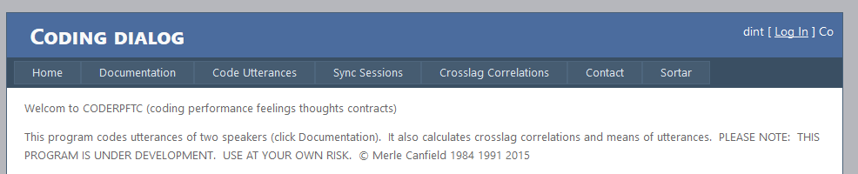

Clicking on the Documentation tab bring up this document.

Clicking on the Code Utterances tab

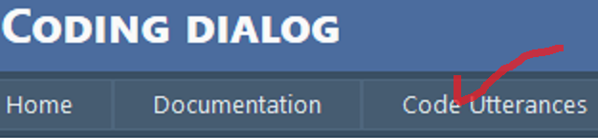

will bring up the following screen.

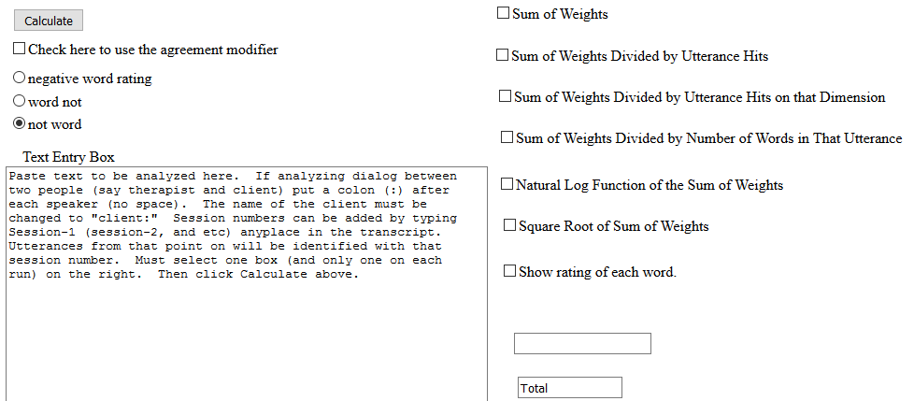

For most runs there are 3 choices to make.

1. Paste the dialog or text that you wish to have analyzed in the box that begins with the phrase “Text Entry Box.”
2. Check one of the seven boxes the type of procedure the analyze the data. For example, the “Sum of Weights” box is checked here. And our sample data from above has been pasted in the “Text Entry Box”

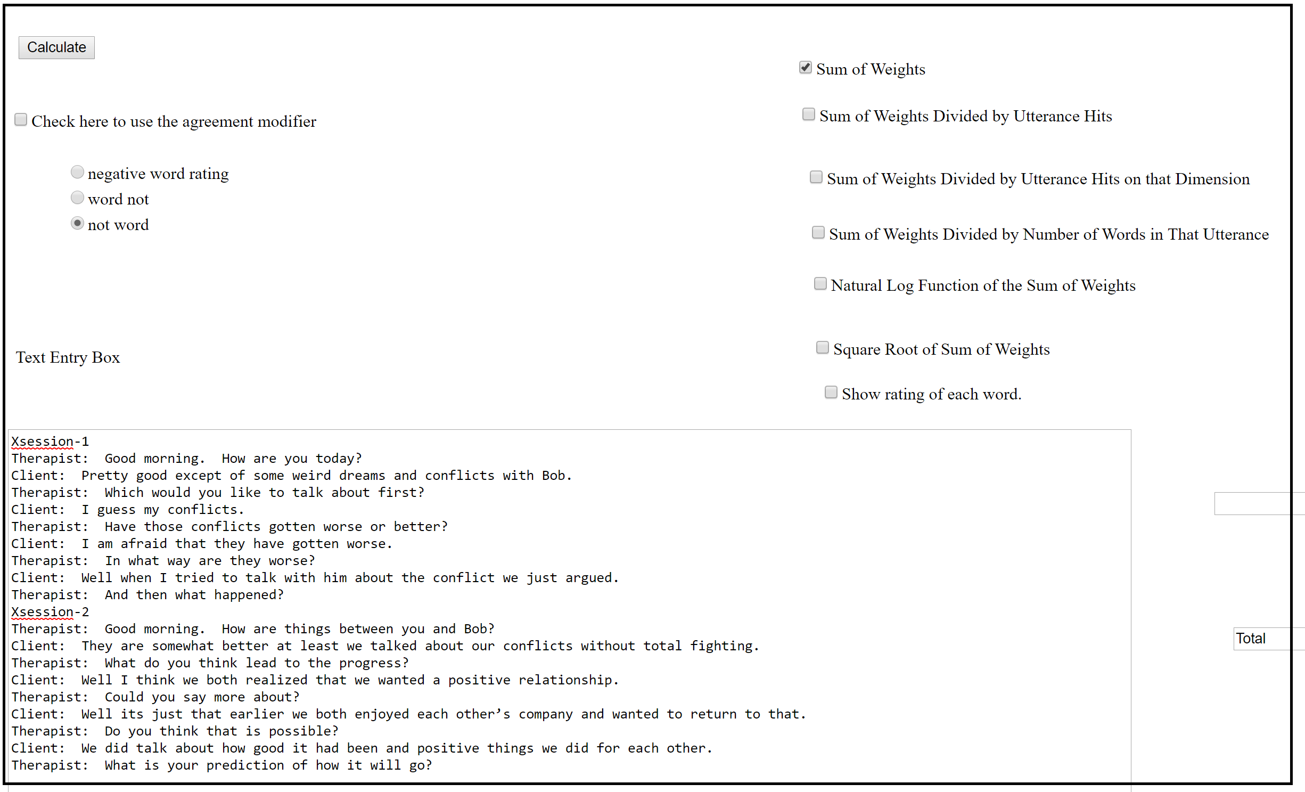

Descriptions of the various methods are given below.

1. Finally click the button up in the left hand corner of the dialog box.

An Excel file will be presented (you must have Excel on your system) for you to download like this:

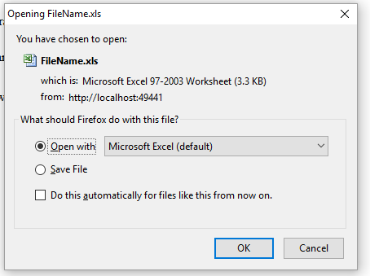

Click OK and depending on your browser the following pop up will appear:

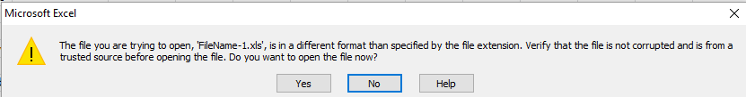

If it does not appear open Excel and click on one of the Excel cells and it should appear. Then click Yes on the pop up box.

The output from that analysis follows:

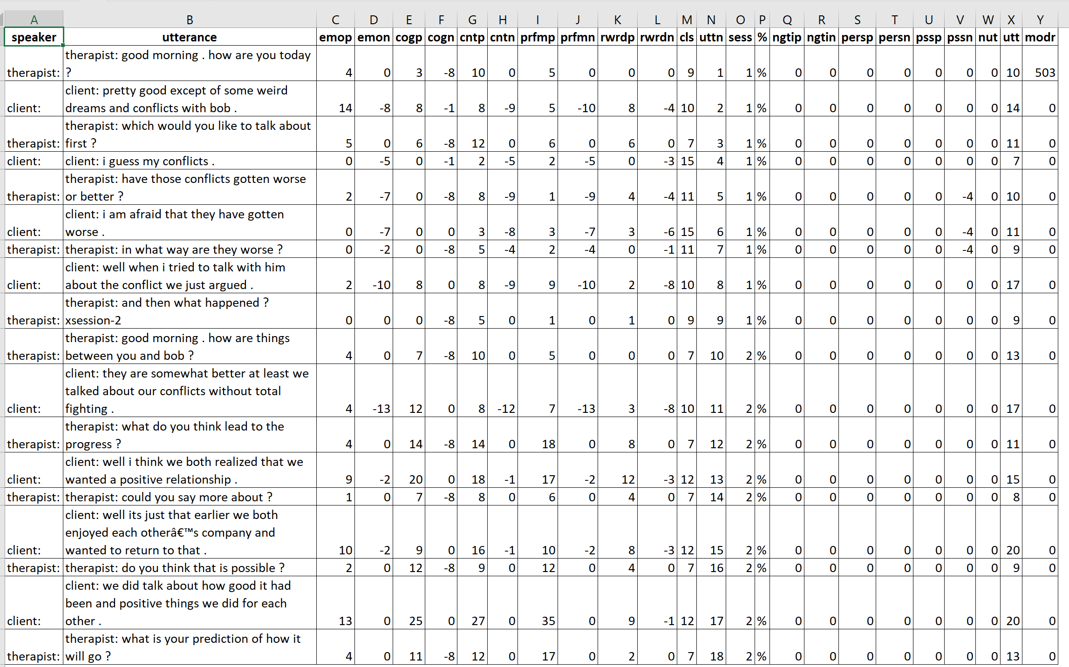

The dimensions of emop, emon, cogp and etc are explained in chapter __. The “cls” is a rating of the utterance that is described in chapter ___. The column labeled “uttn” is the utterance number. In this instance there was just one session identified by “sess”. The percent (%) column is described later. The columns ngtip, ngtin, persp, persn, pssp, pssn, and nut are not used at this time. The column utt is the number of words in the utterance (punctuations are counted as words). The “modr” column is used by the system for various purposes by the system. This file can be loaded directly into SPSS or other statistical systems for analysis.

The next section adds sessions to the process. The added session (or sessions) could be repeated psychotherapy sessions by the same therapist and client for could be another client with the same therapist or a different therapist and a different client or any combination thereof. There is a limit of 5,000 sessions. The procedure for identifying separate sessions is as follows. At the start of each new session the word xsession-1 (or xsession-2, xsession-3 and etc) is entered on a separate line followed by a blank space. There is *no spaces* between xsession, the hyphen and the number. The following is not allowed “xsession -2”, or “xsession- 2.”

One of the programs in the Psychcoder system computes crosslagged correlations. Each of the dimensions of the client’s utterance is correlated with the dimensions of the therapist. It is crucial in such an analysis that each utterance of the client be followed by the therapist. No matter how the conversion of speech to text there seems to be an inevitable instance when either the thereapist or the client either misses and turn or somehow gets recorded twice. Consequently, Psychcoder provides a program which assures “turn-taking.”

Implement the _______ program in the following manner. One of the two people must be labeled as “client” but the second person can have any label – therapist, counselor, or friend. Also either the first or second utterance must be the client. The input into the by first clicking on **sync sessions** as follows:

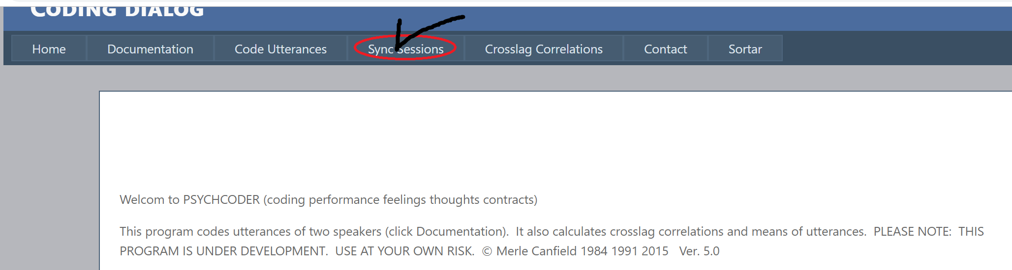

The following screen will appear. Copy the contents from the Excel file that was generated by the Code Utterances above and paste it into the open box. The figure presents the output from above in the box as well as the default choices of the program.

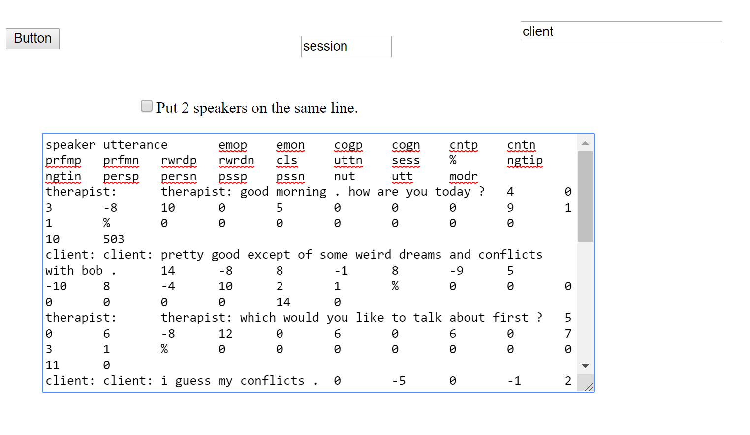

The following Excel is generated:

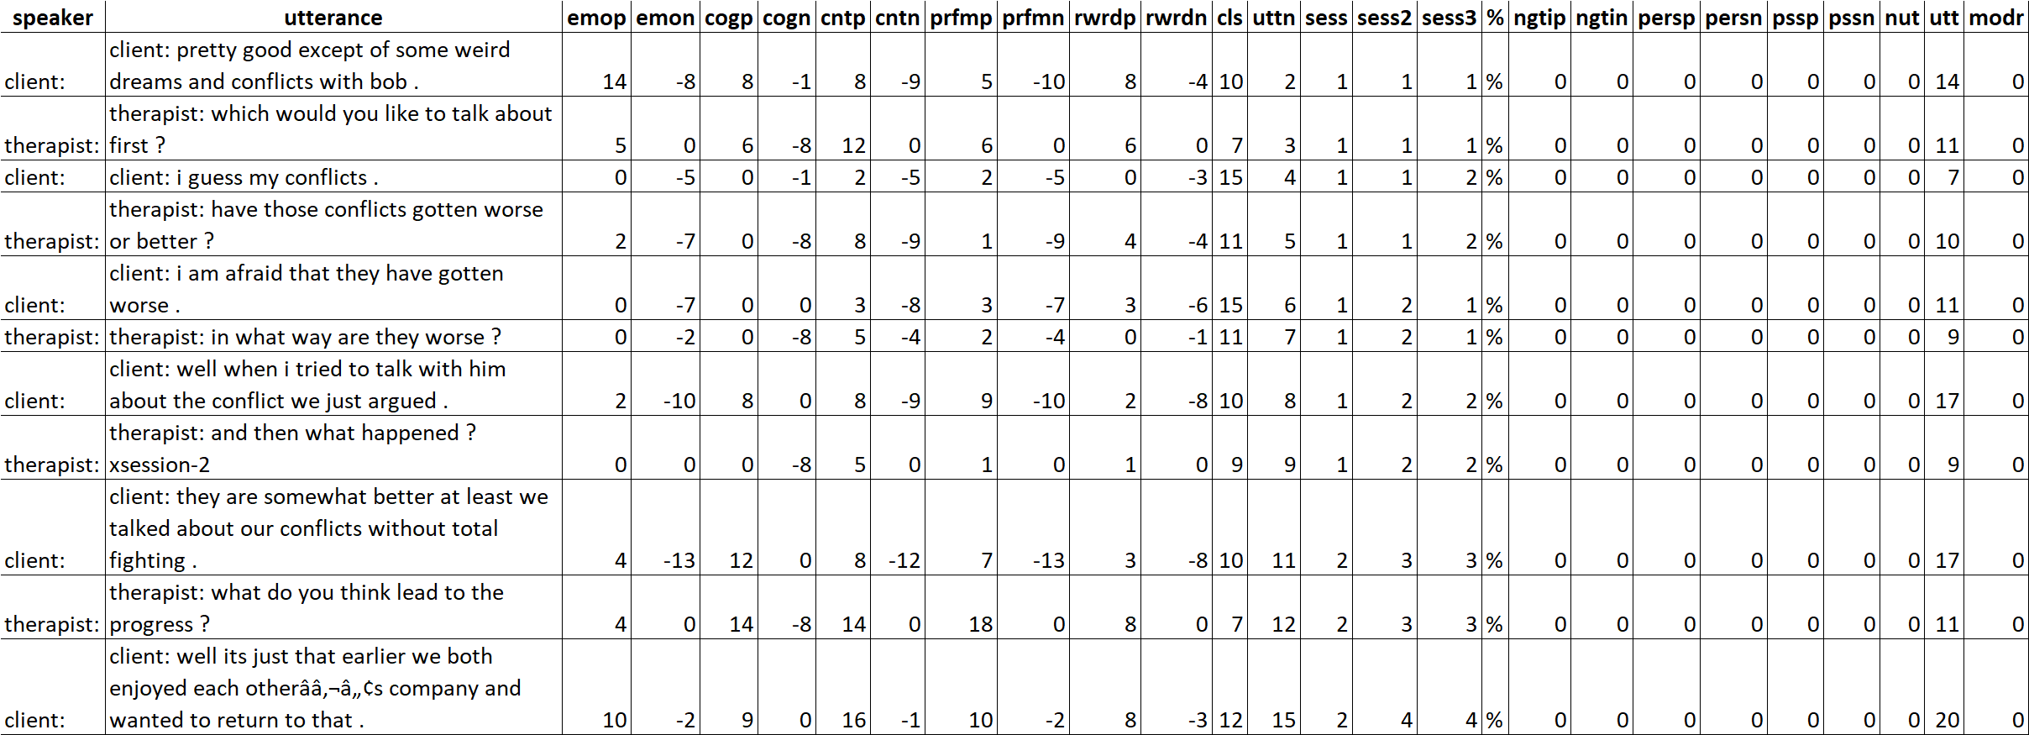

Then next you need to determine what sets of the two sessions you want to compare. Notice that there are 3 columns identified as sess, sess2, and sess3. If you want to compare xsession-1 to xsession-2 then you need to retain sess and delete sess2 and sess3. If you want to compare the first halves of sessions with halves of sessions then delete sess and sess3 and rename column sess2 to sess. If you want to compare all of the firsts with all of the seconds then delete sess and sess2 and rename sess3 to sess. We have chosen to compare xsession-1 with xsession-2 and so have deleted columns sess2 and sess3 and then selected the columns as shown to be copied to the following:

Although it looks quite difference the contents are a direct copy from the above Excel file. There are three defaults: (1) the upper right box indicates the output from this program will be on the first line followed by the second speaker (and will remain throughout the file). (2) the “session” box indicates that the file will be ordered in terms session and not be number of utterances. This is important in the following manner. If the first utterance is by the therapist (or whoever the other speaker may be) that utterance will be dropped because it is being indicated that the client must be the first speaker. (3) if one is analyzing data using SPSS it may be desirable to have the client and therapist on the same line. That is accomplished by checking “Put 2 speakers on the same line.” It should be noted that if in either sessions or number (unless there is only one session) that is there is an odd number of uttereances in a session or set of that there will be one uttereance dropped. In crosslagged correlations there must be and even number of uttances. If there is an odd number of utternaces and the first speaker is the client (and the client is selected to be first) then the last utterance will be dropped.

If the crosslagged correlations are to be computed then the following selection is made.

|  |  |  |  |  |  |  |  |  |  |  |  |  |  |
| --- | --- | --- | --- | --- | --- | --- | --- | --- | --- | --- | --- | --- | --- |
| **emop** | **emon** | **cogp** | **cogn** | **cntp** | **cntn** | **prfmp** | **prfmn** | **rwrdp** | **rwrdn** | **cls** | **uttn** | **sess** | **%** |
| 14 | -8 | 8 | -1 | 8 | -9 | 5 | -10 | 8 | -4 | 10 | 2 | 1 | % |
| 5 | 0 | 6 | -8 | 12 | 0 | 6 | 0 | 6 | 0 | 7 | 3 | 1 | % |
| 0 | -5 | 0 | -1 | 2 | -5 | 2 | -5 | 0 | -3 | 15 | 4 | 1 | % |
| 2 | -7 | 0 | -8 | 8 | -9 | 1 | -9 | 4 | -4 | 11 | 5 | 1 | % |
| 0 | -7 | 0 | 0 | 3 | -8 | 3 | -7 | 3 | -6 | 15 | 6 | 1 | % |
| 0 | -2 | 0 | -8 | 5 | -4 | 2 | -4 | 0 | -1 | 11 | 7 | 1 | % |
| 2 | -10 | 8 | 0 | 8 | -9 | 9 | -10 | 2 | -8 | 10 | 8 | 1 | % |
| 0 | 0 | 0 | -8 | 5 | 0 | 1 | 0 | 1 | 0 | 9 | 9 | 1 | % |
| 4 | -13 | 12 | 0 | 8 | -12 | 7 | -13 | 3 | -8 | 10 | 11 | 2 | % |
| 4 | 0 | 14 | -8 | 14 | 0 | 18 | 0 | 8 | 0 | 7 | 12 | 2 | % |
| 10 | -2 | 9 | 0 | 16 | -1 | 10 | -2 | 8 | -3 | 12 | 15 | 2 | % |

This sample is taken from the Excel file produced by the Sync Sessions program and not taken from the original run from the Code Utterances run. This is important because there may have been repeated utterances in the original analysis. At any rate this data is pasted into the Crosslagged Correlations run – see the web page next.

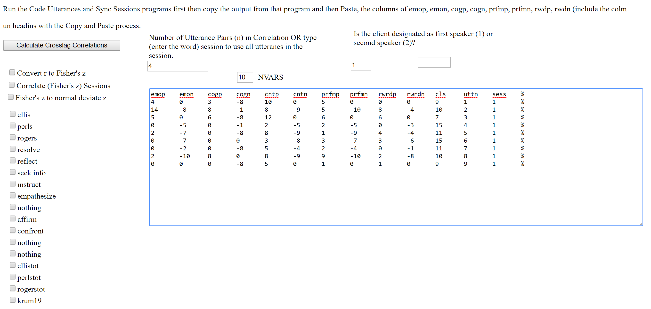

Chapter 3

**Two Methods of Coding Text**

Merle Canfield, Chris Robbins & Mike Robbins

This chapter presents two methods of coding dialogue or text: (a) words and utterances are coded on the dimensions of Contracts, Cognitions, Emotions, Performance, Reward, and Person; and (b) words and utterances are coded on the 15 content dimensions of Non-Information Social Responses, Gathering Information/General, Clarifying and Asking for Information, Positive Agreement, Clarification, Uncertainty, Uncertainty w/Speculation, Agreement w/Uncertainty, Information Gathering/Relationships and Beliefs, Positive and Negative Statements, Questions Involving Values, Belief Statements, Questions Involving Emotions/Attitudes, Challenges, and Positive Statements. The dimensions of Contracts, Cognitions and Contracts are described in Canfield, Walker and Brown (1991), Canfield (1991) and Canfield, Walker, Griffin, Dempsey and Townsend in Chapter 8 of this manual.

***Procedure for Running the CODE Program***

The text to be coded may be produced by many different sources: (1

1) **Sum of weights**

This response provides the sum of weights within a semi‑dimension. NOTE: semi‑dimension is defined as the positive or negative side of each dimension excluding "0". Consequently, for the semi‑dimension of positive emotion, it would be the sum of the ratings that have been rated as positive emotion.

2) **Divide sum of weights of the semi‑dimension by hits in utterance**

This response takes the same numbers that were summed and divides by the number of words in the utterance that were found in the dictionary.

3) **Divide sum of weights of the semi‑dimension by hits on that semi‑dimension**

This establishes a semi‑dimension for each of the four major dimensions resulting in information concerning directionality and weight; for example, positive emotion divided into positive emotion, negative emotion divided into negative emotion.

4) **Divide sum of weights of the semi‑dimension by the number of words in utterance**

The same weights are used, but they are divided by the total number of words in the utterance. The difference in this choice is that the divisor is the total number of words in the utterance rather than the hits in the semi‑dimension.

5) **Natural log function of sum of weights**

The log of the sum of weights within a semi‑dimension.

6) **Square root of sum of weights**

The square root of the sum of weights within a semi‑dimension.

7) **Show rating of each word.**

Shows the rating of each word that you have entered in the Text Entry Box and has a rating in the system dictionary.

In the output, each of the dimensions are abbreviated. The abbreviations are listed below. A "p" added to the abbreviation indicates positive while an "n" indicates negative.

**emo** = *emotion*-‑an utterance containing an emotional component. The numbers under the abbreviation indicate the amount of emotion and whether it was positive or negative.

**cog** = *cognition*‑-an utterance containing a cognitive component. The numbers under the abbreviation indicate the amount of cognition and whether it was positive or negative.

**cnt** = *contract*--an utterance containing an implicit expectation, such as words involving values, relationships or arrangements, each with implied acts to be performed, reinforced or sanctioned. The contract may be given or received. The numbers under the abbreviation indicate the amount of contract and whether it was positive or negative.

**prfm**= *performance*--the degree to which a contract is carried out. Example: negative performance may be *not* performing an agreed upon contract or negative performance may be *performing* a negative contract.

**ngti** = *negotiation*--this dimension is not rated at this time.

**pers** = *person*--the person ratings have two meanings. If the rating is greater than 0 (zero,) the word denotes a person. The magnitude indicates distance of the person in terms of intimate relationship. For example, the words spouse, wife, husband or mate would have a rating of 1 (one) to indicate very little distance in intimate relationship. Sibling, brother, sister, or parent would have a rating of 2, indicating slightly more distance in intimate relationship. Friend would have a rating of 3.

**rwrd**= *reward value (reinforcement)*--degree of reinforcement or reward value.

**cls=** *cluster number* **–** see below**.**

**pss** = *psychosocial setting-*-the degree to which this word describes a setting (there are no negative ratings). Examples include: army = 4, atmosphere = 5, clinic = 6.

**nut** = total number of words in the utterance.

**hit** = this is the number of words in an utterance that the program found in the dictionary.

**utnum** = *utterance number*--corresponds to the sequential numbering of utterances.

At the end of each utterance, the seven dimensions are summarized. Further, the dimensions that are bi-polar are each separated into two semi-dimensions. These separated dimensions are emotion, cognition, contract, performance and reward. Consequently, the summarized dimensions are positive emotion, negative emotion, positive cognition, negative cognition, positive contract, negative contract, positive performance, negative performance, positive reward, and negative reward. These summaries are averages based on the selections above.

The follow

The following is an example of the program output.

Chapter Four

**Code File (Content Coding)**

Merle L. Canfield, Chris Robbins, Mike Robbins

The program codes the utterances according to the 15 content areas (cluster codes – cls) that have been created. It takes the ratings described above and computes the distance between a given utterance and the 15 content areas. These ratings (cluster codes) were created by the Code Mentoring Group 1992‑93 (Canfield, M.; Robbins, C.; Robbins, M.)

***Cluster Descriptions--Content***

The following is a description of the cluster codes (identified as cls in the output). If an utterance has approximately the same profile as a cluster, it receives a high rating on that cluster. If the profile is unlike the cluster profile, it receives a low rating on the cluster. The charts below present profiles for each of the fifteen clusters.

Cluster #1 **Non-Informative Social Responses**--general social responses to "chit-chat"--no information is communicated. These utterances would be considered to be generally acceptable social responses in ordinary conversation.

Examples: Client: "How do you do, Doctor."

Interviewer: "Hello, Jane."

Anyone: "I see."



Cluster #2 **Gathering Information/General**--asking for information; gathering information. Generally, these either start with a question followed by a statement of explanation, or are merely questions asked for the purpose of gathering information. The question may be rhetorical or actual.

Examples: Therapist: "Now, if I am really hurt, if I would cry, what would you do with me?"

Client: "Well, you know what I believe? I believe you are the type of person...sort of...you act like it would not hurt your feelings, but it would. You act strong, but you are vulnerable inside there too. I think your feelings could be hurt, for sure. But I don't show it very easy."

Therapist: "Do you feel like, now that you look back, did you like that period or did you dislike it or....?"



Cluster #3 **Clarifying and Asking for Information**--informationhaving been gathered, the speaker asks for clarification of the information given. Perception checking or paraphrasing may also be used.

Examples: Jane: "Of course, I do not like thinking of myself that way. I want to put myself on a higher standard. I do not like to think that I may be just an average Jane Doe."

Therapist: "So you are generalizing there. You are saying, 'it probably would be that I did have a more difficult time,' but then you are jumping to, 'therefore, I did never get it at all.' You see the catastrophizing there that you have jumped to?"

Interviewer: "But do you look at that and say, 'uh, your values are wrong or your values are different?'"



Cluster #4 **Positive Agreement**--agreeing in a positive way with what has previously been said. There may be further information given or there may be just a positive agreement statement made.

Examples: Therapist: "This is quite true. Our contact is much too superficial to be involved in for you as far as you are right now my client--I care for you as far as I would if I were an artist bringing something out which is hidden in you. This is as far as I care."

Jane: "That is what I am saying, but...."

Client: ` ` "Okay."



Cluster #5 **Clarification**--further understanding is sought. The purpose of these utterances is to bring vague material into sharper focus. The listener may ask for clarification when he/she cannot make sense out of the speaker's utterance. The utterances may also reflect feelings of confusion.

Examples: Therapist: "One of the things you really deeply want is to find a father whom you would love and respect and who would really like you as you are, and not to just like perfection."

Client: "Well, they may value the system of politics. You know, the system of getting what they want, more than they value always being the most truthful. Getting what they want may be of more value to them than always telling the truth."

Interviewer: "You want to be creative and use more original ideas for kids to like school."



Cluster #6 **Uncertainty**--speaker is not certain; may require further information or time to feel certain. The speaker may appear to respond in a vague way indicating perhaps the need for more time to respond with certainty.

Examples: Client: "Well, I do not know."

Client: "Yeah, in a way."

Interviewer: "You may not know it all, but something."



Cluster #7 **Uncertainty with Speculation**--speaker is not certain but has an idea about how to solve or fix the situation. This is indicated by statements such as, "I guess" and "I do not know because..." The speaker may also make a speculative statement, adding, "but I do not know."

Examples: Client: "Well, OK, I'd just like more of it, I guess."

Interviewer: "I do not know because I am going on to be a teacher. I just think in that sense you can give kids some objects, hands one, and all of a sudden they realize, 'Oh this happens,' and they exchange it and they add that on and they learn through experience. Whatever you want to call that."

Client: "I was going to say, people always say that you could open a restaurant and that you could manage it and also cook. But I do not know."



Cluster #8 **Agreement with Uncertainty**--speaker agrees but is not certain. The speaker may make a statement, adding further information that seems to reflect uncertainty on the part of the speaker. The word "maybe" is the key word in the uncertainty.

Examples: Client: "It is something I am doing--it is something I am doing not to be as real a person with these men that I am interested in."

Client: "Well, I would like to be married...maybe. When I am 31."

Interviewer: "Maybe you have refined them."



Cluster #9 **Information Gathering/Relationships & Beliefs**--speaker is seeking further information regarding relationships and/or beliefs. These are usually in the form of a question, but can be rhetorical. The questions seem to be genuinely information seeking.

Examples: Interviewer: "Why not? If he is an eligible individual, any kind of eligible individual."

Interviewer: "Do you ever see yourself, do you ever try to look ahead?"

Client: "Were you involved with peacemaking?"



Cluster #10 **Bipolar Statements**--speaker is giving information that is positive or negative at the beginning of the utterance and ending with the opposite type of information (negative or positive). It appears that the speaker is clear in one direction (either positive or negative) at the beginning of the utterance, but the direction has changed by the end of the utterance.

Examples: Interviewer: "If you are in love with someone, it is maybe not exactly the feeling of love but it may be the feeling of satisfaction or happiness that comes from it."

Client: "Not really. I mean, I might say that I hate something but I do not think I hate, I mean when I say something like that it is not that I hate a person, but that I hate doing something more."

Client: "But mostly a long relationship. I do not think so much of marriage as a long relationship."



Cluster #11 **Questions Involving Values**--speaker is asking questions that directly relate to values. The questions may also be rhetorical.

Examples: Therapist: "Would you jump on me if I would cry?"

Interviewer: "Does jealousy go along with not trusting?"

Interviewer: "Just your personal values and...what is wrong with this world."



Cluster #12 **Belief Statements**--speaker is making statements regarding her/his beliefs. These are personal belief statements based on life experience.

Examples: Therapist: "That is right. You did not have to cover up your anger with your smile, in that minute, you were not a phony."

Client: "There are different kinds of characteristics. You value different kinds of characteristics in a person. I mean, that determines, back to relationships, that determines the kind of relationship that you have."

Client: "Right now I do not feel I am involved in the community as far as _____. But then I am not home that much either. Just during the summer so..."



Cluster #13 **Questions Involving Emotions/Attitudes**--speaker is asking questions related to emotions and/or attitudes. Further clarification usually occurs after the question is asked, but not always. When there is further clarification, more information is given regarding the speaker's emotions and/or attitudes, thus giving the listener more information about the speaker.

Examples: Therapist: "It sounds like a triangle to me, isn't it. You feel that I, or therapists in general, or other people say, 'it is all right, it is all right, it is natural enough, go ahead,' and I guess you feel your body sort of winds up on that side of the picture. But sometimes you say, 'but I don't like it that way, not unless it is really right.'"

Interviewer: "So there can be negative learning?"

Interviewer: "I had kind of a hard time with that movie because it did not seem real and yet it did. I thought about what I would feel if that actually happened. It is just incredible when you think about stuff like that. How about when you hear or see pictures of hungry kids and stuff like that?



Cluster #14 **Challenges**--speaker is confronting the listener, perhaps trying to elicit a particular response. These are generally very straight forward challenges.

Examples: Therapist: "What is your objection?"

Therapist: "The phrase that comes to my mind--I don't know if it is appropriate or not--'you're slapping your father in the face.' Aren't you?"

Interviewer: "A systematic way of doing it. Is that how you do things? If you have a problem, do you do it systematically or do you...?"



Cluster #15 Positive Statements.



Chapter 4

**Counting and Numbering Utterances**

Merle Canfield, Chris Robbins, Mike Robbins

This section provides the steps needed to number the utterances. This can be useful when analyzing segments of a dialogue.

Select:

**Number the Utterances in a file**

The utterances in the file *.ANL will contain numbers as follows:

___________________________________________________________________________

|  |
| --- |
| EXAMPLE: "**D.ANL File"**  1***  E: Hello , Jane  2 0 2  emo cog cnt prfm ngti pers rwrd pss nut hit utnum  200 0 0 0 200 0 200 0 0 0 800 0 0 0 0 10 3 1  2***  G: How do you do .  0 0 0 0 0 0 0 0 0  emo cog cnt prfm ngti pers rwrd pss nut hit utnum  0 0 0 0 0 0 400 0 400 0 600 0 0 0 0 9 3 2  3***  E: Will you be seated please ? Well , would you like to tell  3 2 3 0 0 0 5 0 4 0‑8 5 0 0 2 0 0 0 4 0 4 0 5 3  me what's bothering you ?  ‑3 2‑4 0 0 0 0‑8 5  emo cog cnt prfm ngti pers rwrd pss nut hit utnum  400‑300 300‑800 371‑400 533‑400 400‑200 1800 0‑200 0 19 11 3 |

The number will appear number above each utterance, such as **1\*\*\*** (see above.) Each utterance is sequentially numbered and the words are rated according to the categories described in Chapter 2.

A series of abbreviations with numbers beneath them follows each utterance:

emo cog cnt prfm ngti pers rwrd pss nut hit utnum

0‑300 200‑0 etc. (there is an implied decimal point 2 places to the right)

pos‑neg pos‑neg etc.

Chapter 5

**Methods of Analyzing**

**Correlation Matrices**

**and**

**Comparing Means**

Merle L. Canfield, Joy Elaine Canfield

A number of methods may be used to analyze the data from the Coding System. The system allows the user to compare either sessions or segments of sessions. The comparisons may be made using dimensions or clusters (Chapter 3). The comparisons may be: (a) of the means of the dimensions, (b) of the means of the clusters, or (c) of the cross-lagged correlation matrices. The comparison of means is the most straight forward. For example, the researcher may be interested in whether two written passages contain differing amounts of positive or negative emotion. The two passages could be coded using CODE and the means could be compared on Positive Emotion and Negative Emotion.

The following example compares the means of emotion, cognition, contract, performance and reward for two different sessions. The means of these dimensions are compared using MANOVA. Run the coding program by typing CODE (see Chapter 2). The following screen will appear.

Two files will be generated by these two runs and will be labeled CODTST1.DBF and CODTST2.DBF. These files can be imported into the SPSS statistical package. The following frames demonstrate how to run the SPSS MANOVA program (Windows version 6.1).

Select **Windows** from the menu. The Windows screen appears and the following is found among the icons:



Double click on the graph icon (above) as the arrow indicates and the following screen appears:

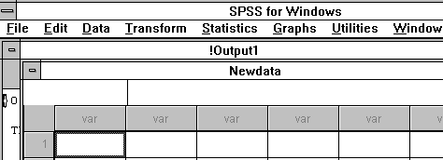

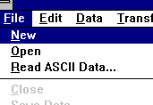

Click on **File**.

Click on **Open**.

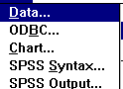

Click on **Data**.

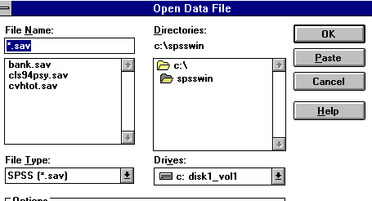

Fill in the **File Name:** and **File Type:** boxes as shown below:

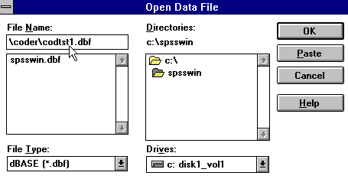

Click **OK** and the data will be loaded into the SPSS desktop. At the end of the Newdata file (to transfer, press **END**), the variable name **SESS** appears. This variable contains the number entered when the Code program was executed.

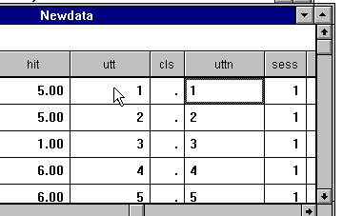

The file is saved as follows:

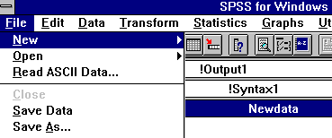

Click on **File**.

Click on **Save As...**

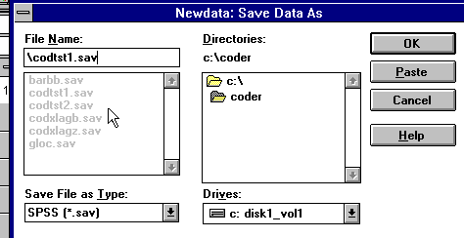

Enter the file name in the **File Name** box as above ensuring that the subdirectory is correct (**coder** in this example).

Click **OK**.

The second file, CODTST2.DBF, can be merged with this file in the following manner. Import CODTST2.DBF and save the file. Use the same method as described for CODTST1.DBF. CODTST2.SAV will appear in the data window and may be merged with CODTST1.SAV.



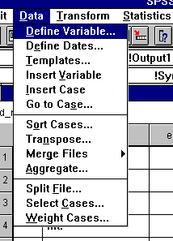

Click on **Data**.

Click on **Merge Files**.

Click on **Add Cases**.

Enter the file name in the **File Name** box as above (\coder\codtst1.sav).

Click on **Continue**.

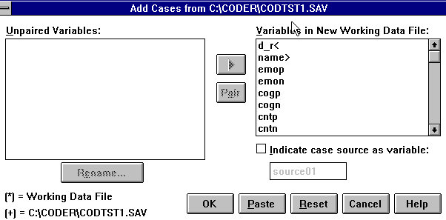

Click on **OK**.

Click on **File**.

Click on **Save As**.

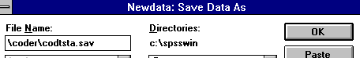

Enter the new file name in the **File Name** box.

Click on **OK**.

Tests of significance between the two sessions are computed as follows:

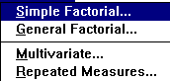

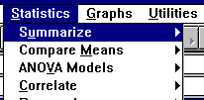

Click on **Statistics**.

Click on **ANOVA Models**.

Click on **Multivariate**.

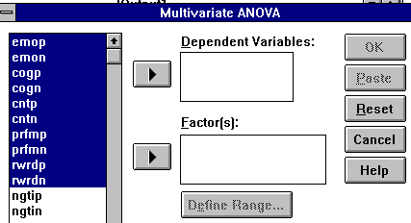

Select the **emop** through **rwrdn** variables as follows:

Set the pointer at **emop**

Hold down the left mouse button

Drag the pointer to **rwrdn**.

Click on the button next to the **Dependent Variables** box.

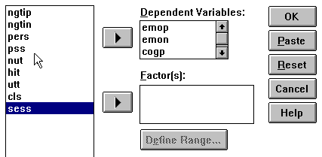

To select **sess:**

Set the pointer to **sess**

Press the left mouse button

Click on the button between **sess** and the **Factor(s):** box.

Click on **Define Range...**

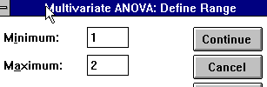

Enter **1** in the **Minimum** box and **2** in the **Maximum** box as indicated in the above frame.

Click on **Continue**.

Click on **OK**.

The results can be found in the output window.

The same procedure can be used for sessions that were created using the CODEC program.

Chapter 6

**Generating Cross‑Lag**

**Moving Correlation Matrices**

Merle L. Canfield, Chris Robbins, Mike Robbins

Lagged correlations are considered measures of contingency. Contingency has been studied with the use of transitional probability matrices utilizing categorical data (Gottman, 1979). Transitional probability matrices are appropriate when utterances are coded into mutually exclusive categories. The comparable analysis for continuous variables is the lagged correlation matrix. Further advantages to the analysis of lagged matrices will be discussed below (Canfield, 1985).

The unit of analysis in lagged correlations is the sequential relationship of the rated scores of utterances. In the coding system, each utterance receives a rating on ten different dimensions: positive emotion, negative emotion, positive cognition, negative cognition, positive values (contracts), negative values (contracts), positive performance, negative performance, positive reward, and negative reward. An utterance may receive a rating in more than one of the categories (Canfield, 1985).

Each correlation coefficient (or covariance) of the lagged correlation matrix (LCM) indicates the probability of the occurrence of a client response to the utterance of the therapist. For example, if the client makes an emotional response, what is the response of the therapist? If the contingency correlation between emotional responses is high, then the therapist is likely to make an emotional response to the emotional utterance of the client (Canfield, 1985).

The lagged correlations reflect how the stimulus of the first person influences the response of the second person. The analysis is based upon a set of contingencies. For example, to what extent does the rating of the utterance of the first person influence the utterance rating of the second person? It can be seen that this method of analysis will show the contingency of one behavior upon another. This ???method??? has been proposed by Barnabie, Cormier, and Nye (1974) and Wampold and Margolin (1982) (Canfield, 1985).

The two methods of coding discussed in the two previous chapters include: (a) the method that uses the original ratings of the dictionary, and (b) the method that uses the original ratings to develop profiles of utterances. Consequently, there are two methods of computing crosslagged correlations corresponding to the two coding methods. The two methods are performed very similarly, however, the results are considerably different.

The CODXLAGM program described in this chapter computes "moving correlations." The number of utterances for each correlation is specified and a correlation matrix for the first nth utterances (number of utterances specified) is computed. The example below indicates 12 utterances or 6 pairs. The N (number of cases for the correlations) in this example is 6. Utterances 1 through 12 are used in the computation of the first correlation matrix followed by an advancement of 2 utterances. Utterances 3 through 14 are used in the computation of the next correlation matrix. The number of pairs (or cases) remains the same at 6. Another advancement of 2 utterances follows as well as another correlation matrix that is computed by using utterances 5 through 16. This procedure is repeated throughout the remainder of the file. If there is an odd number of utterances in the file, then the last utterance is not used. If the therapist is the first speaker in the session, then the moving correlations represent the client following the therapist. In order for the therapist to follow the client, the first utterance (that of the therapist) must be removed.

*Crosslag Correlations of the Original Dimensions*

The following steps are used to compute the moving crosslagged correlations.

Select

**Generate Cross Lag Correlations (Dimensions)**

**View Cross Lag Correlations (Dimensions)**

|  |
| --- |
| X0 X10 X20 X30 X40 X60 X70 X80 X90 AVGCOR UTTNUM  12 17 17 16 7 6 9 3 2 0.37 12  18 11 19 8 11 8 9 3 2 0.38 14  16 10 18 10 9 6 10 5 1 0.39 16  14 13 8 16 10 11 11 6 1 0.42 18  16 11 12 20 9 12 6 6 3 0.39 20  10 13 11 15 13 11 10 7 0 0.43 22  12 15 16 17 7 6 9 6 2 0.39 24  16 11 14 15 10 7 7 10 3 0.40 26 |

To view additional information in this file:

Press <**ESC**>

The correlation matrix will appear. (See example below.)

View and edit fields.

|  |
| --- |
| Number utterances in the correlation is 12  Number of the utterance is 12  Columns identifies 1st speaker; Rowss identifies 2nd speaker  emop emon cogp cogn cntp cntn prfmp prfmn rwrdp rwrdn  emop 0.38 ‑0.57 0.25 0.16 ‑0.40 ‑0.66 0.01 ‑0.59 ‑0.06 ‑0.70  emon 0.57 0.11 0.14 ‑0.39 0.47 ‑0.21 0.70 0.03 0.50 0.07  cogp ‑0.30 ‑0.34 ‑0.15 0.05 0.25 ‑0.19 ‑0.28 ‑0.04 ‑0.41 ‑0.37  cogn 0.55 0.05 0.22 ‑0.31 ‑0.02 ‑0.12 0.54 ‑0.17 0.60 0.22  cntp ‑0.56 0.60 0.22 ‑0.16 0.35 0.80 ‑0.38 0.83 ‑0.13 0.34  cntn 0.25 0.24 ‑0.43 0.39 ‑0.52 ‑0.03 0.25 ‑0.26 0.13 0.43  prfmp 0.10 ‑0.96 0.01 0.19 ‑0.26 ‑0.85 ‑0.22 ‑0.76 ‑0.37 ‑0.91  prfmn 0.40 0.75 0.43 ‑0.68 0.75 0.49 0.71 0.71 0.76 0.58  rwrdp 0.20 ‑0.69 0.06 0.32 ‑0.43 ‑0.72 ‑0.17 ‑0.66 ‑0.30 ‑0.78  rwrdn 0.21 0.16 ‑0.51 0.29 ‑0.18 ‑0.12 0.31 ‑0.20 0.05 0.32 |

Do you want to save this set of correlations? [quit=q] **y**

Three statements will appear:

# of utterances in the correlation is (Choose an even number) **12** (Example).

(This corresponds with the number of the utterances highlighted on the previous screen [prior to pressing **Esc**.])

"Rows" identifies the first speaker; "Columns" identifies the second speaker.

**NOTE:**  **Esc** will toggle the screens between the Correlation Matrix and Summary of Moving Correlations.

To exit the Correlation Matrix screen, respond to the following question:

Do you want to save this set of correlations? [Quit = **Q**] (See example above)

To save the correlations:

Press **<ENTER>**

or **Q** for Quit or **Y** for Yes

(**N** is the default)

The correlations will be automatically saved to a file called CODTST1.mt1

To **QUIT**, type: **Q**

At the DOT PROMPT,type:

**QUIT**

The following will appear:

C:\CODER>

*Crosslag Correlations of the Cluster Profiles*

Select

**Generate Cross Lag Correlations (Content)**

**View Cross Lag Correlations (Content)**

|  |
| --- |
| X0 X10 X20 X30 X40 X60 X70 X80 X90 AVGCOR UTTNUM  20 27 19 20 18 31 29 24 8 0.49 12  27 24 26 31 21 25 17 18 9 0.44 14  29 35 26 29 24 31 13 12 5 0.40 16  34 29 30 31 17 26 17 16 5 0.40 18  30 35 30 23 31 14 22 11 2 0.39 20  30 27 32 24 37 23 16 9 3 0.40 22  36 41 33 24 22 24 10 4 1 0.35 24  38 39 27 37 37 17 3 2 1 0.33 26 |

To view additional information in this file:

Press <**Esc**>

The correlation matrix will appear. (see example below).

View and edit fields.

|  |
| --- |
| Number of utterances in the total file is 12.  Number of utterances making up the correlation matrix is 12.  "Columnss" identifies the first speaker.  "Rows" identifies the second speaker.  Cls1 Cls2 Cls3 Cls4 Cls5 Cls6 Cls7 Cls8 Cls9Cls10Cls11Cls12Cls13Cls14Cls15  1 0.28 0.36 0.36 0.09‑0.75 0.33 0.70 0.19 0.68‑0.15 0.23 0.33 0.61 0.77‑0.72  2 ‑0.10‑0.04‑0.11‑0.56 0.74‑0.71‑0.89‑0.63‑0.96 0.54 0.02‑0.73‑0.82‑0.83 0.76  3 ‑0.66 0.70 0.64‑0.91 0.21‑0.89‑0.59‑0.84‑0.78 0.95 0.62‑0.73‑0.43‑0.20 0.18  4 ‑0.35 0.54 0.60 0.11‑0.83 0.26 0.78 0.22 0.69‑0.05 0.34 0.49 0.80 0.92‑0.90  5 ‑0.68 0.73 0.65‑0.73‑0.22‑0.53‑0.15‑0.61‑0.28 0.68 0.63‑0.52‑0.09 0.22‑0.17  6 ‑0.26 0.47 0.54 0.21‑0.83 0.34 0.81 0.32 0.75‑0.13 0.30 0.57 0.84 0.93‑0.90  7 0.12‑0.00 0.13 0.51‑0.41 0.35 0.60 0.48 0.54‑0.37‑0.15 0.72 0.68 0.48‑0.56  8 ‑0.12 0.14 0.16 0.37‑0.85 0.53 0.92 0.40 0.89‑0.46‑0.06 0.59 0.80 0.81‑0.82  9 0.21‑0.17‑0.08 0.71‑0.63 0.66 0.88 0.67 0.89‑0.69‑0.32 0.85 0.84 0.64‑0.70  10 ‑0.27 0.06‑0.06‑0.68 0.55‑0.69‑0.77‑0.73‑0.85 0.55 0.07‑0.83‑0.79‑0.70 0.64  11 ‑0.30 0.15‑0.01‑0.59 0.16‑0.36‑0.44‑0.54‑0.41 0.37 0.28‑0.78‑0.43‑0.23 0.36  12 ‑0.40 0.48 0.54 0.10‑0.83 0.14 0.80 0.13 0.62‑0.09 0.13 0.54 0.77 0.78‑0.92  13 0.17 0.02 0.14 0.59‑0.51 0.52 0.71 0.61 0.72‑0.44‑0.07 0.79 0.77 0.65‑0.64  14 0.15‑0.05 0.04 0.57‑0.57 0.54 0.73 0.57 0.76‑0.52‑0.11 0.69 0.82 0.67‑0.63  15 ‑0.41 0.47 0.39‑0.40‑0.31‑0.11 0.07‑0.27 0.07 0.32 0.47‑0.30 0.02 0.33‑0.21  Do you want to save this set of correlations? [quit=q] y |

Three statements will appear:

# of utterances in the correlation is (you can choose an even number) **12** (Example).

(This corresponds to the number of utterances you highlighted on the previous screen [prior to hitting **Esc**]).

"Rows" identifies the first speaker. "Columns" identifies the second speaker.

**NOTE:**  **Esc** will toggle the screens between the Correlation Matrix and Summary of Moving Correlations.

To exit the Correlation Matrix screen, respond to the following question:

Do you want to save this set of correlations? [Quit = **Q**] (see example above)

To save the correlations:

Press **<ENTER>**

or **Q** for Quit or **Y** for Yes

(**N** is the default)

The correlations will be automatically saved to a file called **CODTST1.mt2**

To **QUIT**, type: **Q**

Chapter 7

**Generating Cross-Lag**

**Correlation Matrices**

**For Session and Segments**

Merle L. Canfield Joy Elaine Canfield

In Chapter 5, cross-lagged correlations were described in terms of a single segment or single session. This chapter describes methods of analyzing a number of segments or a number of sessions. The program **Generate Complex Cross Lag Correlations (Dimensions)** is used for these analyses.

The **Number the Utterances in a file** program (Chapter 4) is used to number the utterances and **Generate Complex Cross Lag Correlations (Dimensions)**d is used to analyze specific segments as identified by the utterance number. For example, if the overall session has 20 utterances and the first segment contained 6 utterances, then the next segment should contain 8 utterances and the third segment should contain 6 utterances. ???The first segment begins with the first utterance, the second segment begins with the 7th utterance and the third segment begins with the 15th utterance.???

Two techniques of analyzing cross-lagged correlations are presented. The first technique uses the structural equation modeling method; the second technique uses the Fisher's z method.

*Structural Equation Modeling Method of Comparing Crosss-Lagged Correlation Matrices*

In this example, two sessions, CODTST1.TXT and CODTST2.TXT, are compared. The two sessions are coded according to the instructions outlined in Chapter 3 in which the CODTST1.NUM, CODTST1.DBF, CODTST2.NUM, and CODTST2.DBF files are generated. The *.NUM files are used in this example. There are three considerations in this analysis: (a) who is designated the first speaker and who is designated the second speaker? (b) the file must have an even number of utterances, and (c) the speakers must always alternate. No speaker may have two utterances in succession. Assume that the seven utterances in the following frame comprise a complete interview.

|  |
| --- |
| Clt: So what are we going to talk about this time?  Int: Bull. Are you tired of these interviews?  Clt: Yeah.  Int: I get that feeling. How do you feel about these interviews?  Clt: Tiring. I think about things that I usually don't think about.  Int: Hum. Okay so do you like these or dislike them?  Clt: You mean these interviews? |

???The corresponding CODTST1.NUM.???

| speaker | emop | emon | cogp | cogn | cntp | cntn | prfmp | prfmn | rwrdp | rwrdn |
| --- | --- | --- | --- | --- | --- | --- | --- | --- | --- | --- |
| clt: | 1.5 | 0 | 4.5 | -8 | 4 | 0 | 4 | 0 | 1.33 | 0 |
| int: | 0 | -3 | 3 | -8 | 4.5 | -1 | 2.5 | 0 | 1 | -3 |
| clt: | 0 | -3 | 0 | -5 | 3.5 | 0 | 2.5 | 0 | 0 | -2 |
| int: | 1.5 | 0 | 2.33 | -8 | 3.5 | 0 | 3.67 | 0 | 2.33 | 0 |
| clt: | 1 | 0 | 4 | -6 | 1.5 | -1 | 4.5 | -3 | 1.5 | -1 |
| int: | 2.67 | -5 | 2 | -8 | 3.75 | -4 | 4 | -5 | 2 | -3 |
| clt: | 0 | 0 | 4 | -8 | 3.33 | 0 | 3 | 0 | 1 | 0 |

If the first utterance (Clt: is speaker) were eliminated, then three pairs of utterances would remain. A cross-lagged correlation could be computed. The N would be 3 and the client (Clt:) would follow the interviewer (Int:).

The ???matrix??? would appear as follows:

|  |
| --- |
| Int: Bull. Are you tired of these interviews?  Clt: Yeah.  Int: I get that feeling. How do you feel about these interviews?  Clt: Tiring. I think about things that I usually don't think about.  Int: Hum. Okay so do you like these or dislike them?  Clt: You mean these interviews? |

| speaker | emop | emon | cogp | cogn | cntp | cntn | prfmp | prfmn | rwrdp | rwrdn |
| --- | --- | --- | --- | --- | --- | --- | --- | --- | --- | --- |
| int: | 0 | -3 | 3 | -8 | 4.5 | -1 | 2.5 | 0 | 1 | -3 |
| clt: | 0 | -3 | 0 | -5 | 3.5 | 0 | 2.5 | 0 | 0 | -2 |
| int: | 1.5 | 0 | 2.33 | -8 | 3.5 | 0 | 3.67 | 0 | 2.33 | 0 |
| clt: | 1 | 0 | 4 | -6 | 1.5 | -1 | 4.5 | -3 | 1.5 | -1 |
| int: | 2.67 | -5 | 2 | -8 | 3.75 | -4 | 4 | -5 | 2 | -3 |
| clt: | 0 | 0 | 4 | -8 | 3.33 | 0 | 3 | 0 | 1 | 0 |

T

The resulting correlation matrix would be correlations of client responses to the interviewer. The following frame is accomplished by eliminating the last utterance.

|  |
| --- |
| Clt: So what are we going to talk about this time?  Int: Bull. Are you tired of these interviews?  Clt: Yeah.  Int: I get that feeling. How do you feel about these interviews?  Clt: Tiring. I think about things that I usually don't think about.  Int: Hum. Okay so do you like these or dislike them? |

The corresponding CODTST1.NUM.

| speaker | emop | emon | cogp | cogn | cntp | cntn | prfmp | prfmn | rwrdp | rwrdn |
| --- | --- | --- | --- | --- | --- | --- | --- | --- | --- | --- |
| clt: | 1.5 | 0 | 4.5 | -8 | 4 | 0 | 4 | 0 | 1.33 | 0 |
| int: | 0 | -3 | 3 | -8 | 4.5 | -1 | 2.5 | 0 | 1 | -3 |
| clt: | 0 | -3 | 0 | -5 | 3.5 | 0 | 2.5 | 0 | 0 | -2 |
| int: | 1.5 | 0 | 2.33 | -8 | 3.5 | 0 | 3.67 | 0 | 2.33 | 0 |
| clt: | 1 | 0 | 4 | -6 | 1.5 | -1 | 4.5 | -3 | 1.5 | -1 |
| int: | 2.67 | -5 | 2 | -8 | 3.75 | -4 | 4 | -5 | 2 | -3 |

In this instance, the N is also 3 and the interviewer (Int:) follows the client. The cross-lagged correlation matrix indicates the interviewer responses to the client. It is important to note that these adjustments should take place in the *.NUM files rather than in the text files.

Jobstreams have been supplied for the computation of correlation matrices for CODTST1.NUM and CODTST2.NUM. Although you may plan to restrict your analysis to the comparison of the matrix using structural equation modeling (EQS), this step must be performed to convert the data to a readable format for the EQS program as EQS is limited to reading dBase III files. SPSS converts files from later versions of dBase to dBase III. In the future, EQS may be able to read other versions of dBase and this step will not be required.

In SPSS Windows, perform the following steps:

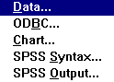

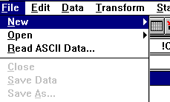

Click on **File**.

Click on **Open**.

Click on **SPSS Syntax**.

Enter the file name in the **File Name** box as follows:

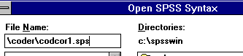

Select the syntax by pressing CTRL A or:

Place the pointer in the top left corner.

Hold down the left mouse button.

Drag the pointer to the bottom of the window.

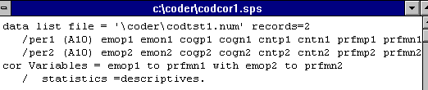

Click on the button as indicated by the arrow below. The button is below the word Utilities.



Click on **Window**.

Click on **Newdata**.

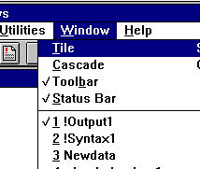

Click on **File**.

Click on **Save As...**

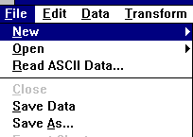

Select dBase III. 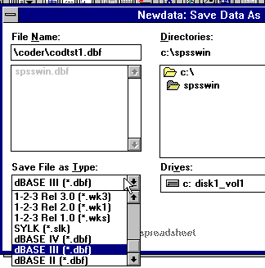

Click on **OK**.

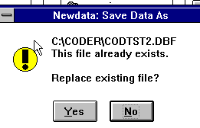

Click on **Yes**.

The procedure must be repeated for each matrix that is to be compared. For example, CODTST1 and CODTST2 could be compared. The first half of the CODTST1 interview could be compared to the second half of the interview when: (a) the Clt follows the Int, and (b) the Int follows the Clt. CODTST1 could also be compared to CODTST2 using these same procedures.

The next step is to compare matrices using the EQS program (LISREL may also be used).

Click on **File**.

Click on **Open**.

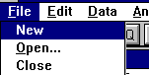

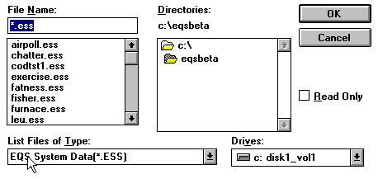

Enter \CODER\CODTST1.DBF in the File Name box and change the List Files of Type to .DBF files as indicated by the following frame.

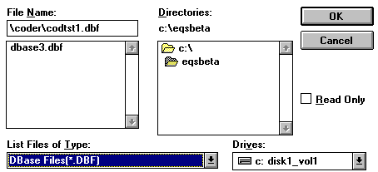

Click on **OK**.

Two variables, PER1 and PER2, must be deleted from the file. This is accomplished by clicking on PER1.

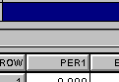

Click on **Edit**.

Click on **Delete**.

Click on **PER2**.

Click on **Edit**.

Click on **Delete**.

Save the file in EQS format (**ESS**).

Click on **File**.

Click on **Save As...**

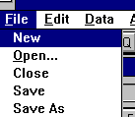

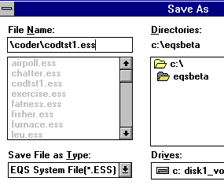

Enter the file name in the **File Name** box as indicated in the above frame.

It is important that the EQS System File (\***.ESS**) is selected in the **Save File as Type** box.

Click on **OK**.

Use the same procedure to retrieve CODTST2.DBF. Save this file as CODTST2.ESS.

Open the TSTMOD1.EQS file.

Click on **File**.

Click on **Open.**

Complete the **Open** window as indicated in the frame below.

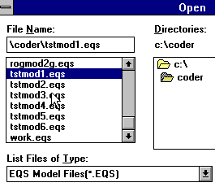

It is necessary to select the correct subdirectory and **EQS Model Files (*.EQS)** in the **List Files of Type** box.

Click **OK**.

At this time, there is a bug in the program (May, 1995), therefore, the file should be saved before running the program.

To run the program:

Click on **Build EQS**.

Click on **Run EQS/386**.

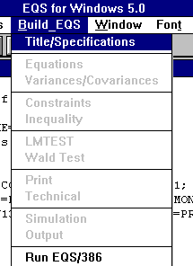

The following is partial output from the EQS run. Of particular interest are: (a) the overall test of significance to determine whether the two correlation matrices are different, and (b) the tests of signficance for each correlation. The overall Chi Square of 189.918 with 117 degrees has a corresponding p value of .00102 indicating that the two matrices are different. The tests of significance for the individual correlations have been??? placed to correspond??? with the constraints for viewing.

GOODNESS OF FIT SUMMARY

INDEPENDENCE MODEL CHI‑SQUARE = 966.621 ON 240 DEGREES OF FREEDOM

INDEPENDENCE AIC = 486.62140 INDEPENDENCE CAIC = ‑503.12996

MODEL AIC = ‑64.08173 MODEL CAIC = ‑546.58552

CHI‑SQUARE = 169.918 BASED ON 117 DEGREES OF FREEDOM

PROBABILITY VALUE FOR THE CHI‑SQUARE STATISTIC IS 0.00102

BENTLER‑BONETT NORMED FIT INDEX= 0.824

BENTLER‑BONETT NONNORMED FIT INDEX= 0.851

COMPARATIVE FIT INDEX = 0.927

LAGRANGE MULTIPLIER TEST (FOR RELEASING CONSTRAINTS)

CONSTRAINTS TO BE RELEASED ARE:

CONSTRAINTS FROM GROUP 2

CONSTR: 1 (1,F1,F3)‑(2,F1,F3)=0; 1 CONSTR: 1 0.135 0.713

CONSTR: 2 (1,F1,F4)‑(2,F1,F4)=0; 2 CONSTR: 2 0.201 0.654

CONSTR: 3 (1,F1,F5)‑(2,F1,F5)=0; 3 CONSTR: 3 0.470 0.493

CONSTR: 4 (1,F1,F6)‑(2,F1,F6)=0; 4 CONSTR: 4 0.771 0.380

CONSTR: 5 (1,F1,F7)‑(2,F1,F7)=0; 5 CONSTR: 5 0.017 0.895

CONSTR: 6 (1,F1,F8)‑(2,F1,F8)=0; 6 CONSTR: 6 1.053 0.305

CONSTR: 7 (1,F1,F9)‑(2,F1,F9)=0; 7 CONSTR: 7 0.666 0.414

CONSTR: 8 (1,F1,F10)‑(2,F1,F10)=0; 8 CONSTR: 8 0.051 0.821

CONSTR: 9 (1,F1,F11)‑(2,F1,F11)=0; 9 CONSTR: 9 1.512 0.219

CONSTR: 10 (1,F1,F12)‑(2,F1,F12)=0; 10 CONSTR: 10 0.115 0.735

CONSTR: 11 (1,F1,F13)‑(2,F1,F13)=0; 11 CONSTR: 11 0.894 0.344

CONSTR: 12 (1,F1,F14)‑(2,F1,F14)=0; 12 CONSTR: 12 1.818 0.178

CONSTR: 13 (1,F1,F15)‑(2,F1,F15)=0; 13 CONSTR: 13 0.102 0.750

CONSTR: 14 (1,F1,F16)‑(2,F1,F16)=0; 14 CONSTR: 14 2.104 0.147

CONSTR: 15 (1,F2,F3)‑(2,F2,F3)=0; 15 CONSTR: 15 4.004 0.045

CONSTR: 16 (1,F2,F4)‑(2,F2,F4)=0; 16 CONSTR: 16 1.793 0.181

CONSTR: 17 (1,F2,F5)‑(2,F2,F5)=0; 17 CONSTR: 17 8.282 0.004

CONSTR: 18 (1,F2,F6)‑(2,F2,F6)=0; 18 CONSTR: 18 0.286 0.593

CONSTR: 19 (1,F2,F7)‑(2,F2,F7)=0; 19 CONSTR: 19 0.651 0.420

CONSTR: 20 (1,F2,F8)‑(2,F2,F8)=0; 20 CONSTR: 20 9.725 0.002

CONSTR: 21 (1,F2,F9)‑(2,F2,F9)=0; 21 CONSTR: 21 0.079 0.779

CONSTR: 22 (1,F2,F10)‑(2,F2,F10)=0; 22 CONSTR: 22 0.513 0.474

CONSTR: 23 (1,F2,F11)‑(2,F2,F11)=0; 23 CONSTR: 23 0.200 0.655

CONSTR: 24 (1,F2,F12)‑(2,F2,F12)=0; 24 CONSTR: 24 2.447 0.118

CONSTR: 25 (1,F2,F13)‑(2,F2,F13)=0; 25 CONSTR: 25 NOT TESTED DU

CONSTR: 26 (1,F2,F14)‑(2,F2,F14)=0; 26 CONSTR: 26 NOT TESTED DU

CONSTR: 27 (1,F2,F15)‑(2,F2,F15)=0; 27 CONSTR: 27 NOT TESTED DU

CONSTR: 28 (1,F2,F16)‑(2,F2,F16)=0; 28 CONSTR: 28 NOT TESTED DU

CONSTR: 29 (1,F3,F4)‑(2,F3,F4)=0; 29 CONSTR: 29 2.008 0.156

CONSTR: 30 (1,F3,F5)‑(2,F3,F5)=0; 30 CONSTR: 30 11.692 0.001

CONSTR: 31 (1,F3,F6)‑(2,F3,F6)=0; 31 CONSTR: 31 0.001 0.973

CONSTR: 32 (1,F3,F7)‑(2,F3,F7)=0; 32 CONSTR: 32 3.773 0.052

CONSTR: 33 (1,F3,F8)‑(2,F3,F8)=0; 33 CONSTR: 33 1.532 0.216

CONSTR: 34 (1,F3,F9)‑(2,F3,F9)=0; 34 CONSTR: 34 0.392 0.531

CONSTR: 35 (1,F3,F10)‑(2,F3,F10)=0; 35 CONSTR: 35 3.086 0.079

CONSTR: 36 (1,F3,F11)‑(2,F3,F11)=0; 36 CONSTR: 36 0.239 0.625

CONSTR: 37 (1,F3,F12)‑(2,F3,F12)=0; 37 CONSTR: 37 2.550 0.110

CONSTR: 38 (1,F2,F13)‑(2,F2,F13)=0; 38 CONSTR: 38 0.957 0.328

CONSTR: 39 (1,F2,F14)‑(2,F2,F14)=0; 39 CONSTR: 39 0.261 0.610

CONSTR: 40 (1,F2,F15)‑(2,F2,F15)=0; 40 CONSTR: 40 0.439 0.507

CONSTR: 41 (1,F2,F16)‑(2,F2,F16)=0; 41 CONSTR: 41 0.238 0.625

CONSTR: 42 (1,F4,F5)‑(2,F4,F5)=0; 42 CONSTR: 42 1.367 0.242

CONSTR: 43 (1,F4,F6)‑(2,F4,F6)=0; 43 CONSTR: 43 0.514 0.473

CONSTR: 44 (1,F4,F7)‑(2,F4,F7)=0; 44 CONSTR: 44 0.209 0.647

CONSTR: 45 (1,F4,F8)‑(2,F4,F8)=0; 45 CONSTR: 45 1.354 0.245

CONSTR: 46 (1,F4,F9)‑(2,F4,F9)=0; 46 CONSTR: 46 1.660 0.198

CONSTR: 47 (1,F4,F10)‑(2,F4,F10)=0; 47 CONSTR: 47 0.185 0.667

CONSTR: 48 (1,F4,F11)‑(2,F4,F11)=0; 48 CONSTR: 48 0.813 0.367

CONSTR: 49 (1,F4,F12)‑(2,F4,F12)=0; 49 CONSTR: 49 1.803 0.179

CONSTR: 50 (1,F4,F13)‑(2,F4,F13)=0; 50 CONSTR: 50 0.127 0.721

CONSTR: 51 (1,F4,F14)‑(2,F4,F14)=0; 51 CONSTR: 51 0.000 0.983

CONSTR: 52 (1,F4,F15)‑(2,F4,F15)=0; 52 CONSTR: 52 1.098 0.295

CONSTR: 53 (1,F4,F16)‑(2,F4,F16)=0; 53 CONSTR: 53 1.660 0.198

CONSTR: 54 (1,F5,F6)‑(2,F5,F6)=0; 54 CONSTR: 54 5.240 0.022

CONSTR: 55 (1,F5,F7)‑(2,F5,F7)=0; 55 CONSTR: 55 0.124 0.725

CONSTR: 56 (1,F5,F8)‑(2,F5,F8)=0; 56 CONSTR: 56 4.075 0.044

CONSTR: 57 (1,F5,F9)‑(2,F5,F9)=0; 57 CONSTR: 57 1.615 0.204

CONSTR: 58 (1,F5,F10)‑(2,F5,F10)=0; 58 CONSTR: 58 1.554 0.213

CONSTR: 59 (1,F5,F11)‑(2,F5,F11)=0; 59 CONSTR: 59 0.198 0.656

CONSTR: 60 (1,F5,F12)‑(2,F5,F12)=0; 60 CONSTR: 60 0.609 0.435

CONSTR: 61 (1,F5,F13)‑(2,F5,F13)=0; 61 CONSTR: 61 0.789 0.374

CONSTR: 62 (1,F5,F14)‑(2,F5,F14)=0; 62 CONSTR: 62 3.840 0.050

CONSTR: 63 (1,F5,F15)‑(2,F5,F15)=0; 63 CONSTR: 63 1.678 0.195

CONSTR: 64 (1,F5,F16)‑(2,F5,F16)=0; 64 CONSTR: 64 3.833 0.050

CONSTR: 65 (1,F6,F7)‑(2,F6,F7)=0; 65 CONSTR: 65 0.896 0.344

CONSTR: 66 (1,F6,F8)‑(2,F6,F8)=0; 66 CONSTR: 66 3.905 0.048

CONSTR: 67 (1,F6,F9)‑(2,F6,F9)=0; 67 CONSTR: 67 0.088 0.767

CONSTR: 68 (1,F6,F10)‑(2,F6,F10)=0; 68 CONSTR: 68 0.074 0.786

CONSTR: 69 (1,F6,F11)‑(2,F6,F11)=0; 69 CONSTR: 69 0.400 0.527

CONSTR: 70 (1,F6,F12)‑(2,F6,F12)=0; 70 CONSTR: 70 0.832 0.362

CONSTR: 71 (1,F6,F13)‑(2,F6,F13)=0; 71 CONSTR: 71 1.414 0.234

CONSTR: 72 (1,F6,F14)‑(2,F6,F14)=0; 72 CONSTR: 72 0.298 0.585

CONSTR: 73 (1,F6,F15)‑(2,F6,F15)=0; 73 CONSTR: 73 0.424 0.515

CONSTR: 74 (1,F6,F16)‑(2,F6,F16)=0; 74 CONSTR: 74 0.078 0.781

CONSTR: 75 (1,F7,F8)‑(2,F7,F8)=0; 75 CONSTR: 75 0.793 0.373

CONSTR: 76 (1,F7,F9)‑(2,F7,F9)=0; 76 CONSTR: 76 2.137 0.144

CONSTR: 77 (1,F7,F10)‑(2,F7,F10)=0; 77 CONSTR: 77 1.431 0.232

CONSTR: 78 (1,F7,F11)‑(2,F7,F11)=0; 78 CONSTR: 78 0.238 0.626

CONSTR: 79 (1,F7,F12)‑(2,F7,F12)=0; 79 CONSTR: 79 0.124 0.725

CONSTR: 80 (1,F7,F13)‑(2,F7,F13)=0; 80 CONSTR: 80 0.022 0.881

CONSTR: 81 (1,F7,F14)‑(2,F7,F14)=0; 81 CONSTR: 81 0.035 0.852

CONSTR: 82 (1,F7,F15)‑(2,F7,F15)=0; 82 CONSTR: 82 0.122 0.727

CONSTR: 83 (1,F7,F16)‑(2,F7,F16)=0; 83 CONSTR: 83 0.949 0.330

CONSTR: 84 (1,F8,F9)‑(2,F8,F9)=0; 84 CONSTR: 84 1.319 0.251

CONSTR: 85 (1,F8,F10)‑(2,F8,F10)=0; 85 CONSTR: 85 2.359 0.125

CONSTR: 86 (1,F8,F11)‑(2,F8,F11)=0; 86 CONSTR: 86 0.306 0.580

CONSTR: 87 (1,F8,F12)‑(2,F8,F12)=0; 87 CONSTR: 87 1.728 0.189

CONSTR: 88 (1,F8,F13)‑(2,F8,F13)=0; 88 CONSTR: 88 0.043 0.836

CONSTR: 89 (1,F8,F14)‑(2,F8,F14)=0; 89 CONSTR: 89 0.001 0.972

CONSTR: 90 (1,F8,F15)‑(2,F8,F15)=0; 90 CONSTR: 90 0.536 0.464

CONSTR: 91 (1,F8,F16)‑(2,F8,F16)=0; 91 CONSTR: 91 0.073 0.787

CONSTR: 92 (1,F9,F10)‑(2,F9,F10)=0; 92 CONSTR: 92 0.142 0.706

CONSTR: 93 (1,F9,F11)‑(2,F9,F11)=0; 93 CONSTR: 93 0.052 0.820

CONSTR: 94 (1,F9,F12)‑(2,F9,F12)=0; 94 CONSTR: 94 1.698 0.193

CONSTR: 95 (1,F9,F13)‑(2,F9,F13)=0; 95 CONSTR: 95 0.311 0.577

CONSTR: 96 (1,F9,F14)‑(2,F9,F14)=0; 96 CONSTR: 96 1.509 0.219

CONSTR: 97 (1,F9,F15)‑(2,F9,F15)=0; 97 CONSTR: 97 7.274 0.007

CONSTR: 98 (1,F9,F16)‑(2,F9,F16)=0; 98 CONSTR: 98 0.717 0.397

CONSTR: 99 (1,F10,F11)‑(2,F10,F11)=0; 99 CONSTR: 99 0.004 0.950

CONSTR: 100 (1,F10,F12)‑(2,F10,F12)=0; 100 CONSTR: 100 1.443 0.230

CONSTR: 101 (1,F10,F13)‑(2,F10,F13)=0; 101 CONSTR: 101 0.274 0.600

CONSTR: 102 (1,F10,F14)‑(2,F10,F14)=0; 102 CONSTR: 102 0.079 0.779

CONSTR: 103 (1,F10,F15)‑(2,F10,F15)=0; 103 CONSTR: 103 0.029 0.866

CONSTR: 104 (1,F10,F16)‑(2,F10,F16)=0; 104 CONSTR: 104 0.357 0.550

CONSTR: 105 (1,F11,F12)‑(2,F11,F12)=0; 105 CONSTR: 105 2.328 0.127

CONSTR: 106 (1,F11,F13)‑(2,F11,F13)=0; 106 CONSTR: 106 2.243 0.134

CONSTR: 107 (1,F11,F14)‑(2,F11,F14)=0; 107 CONSTR: 107 0.039 0.844

CONSTR: 108 (1,F11,F15)‑(2,F11,F15)=0; 108 CONSTR: 108 0.190 0.663

CONSTR: 109 (1,F11,F16)‑(2,F11,F16)=0; 109 CONSTR: 109 4.087 0.043

CONSTR: 110 (1,F12,F13)‑(2,F12,F13)=0; 110 CONSTR: 110 6.863 0.009

CONSTR: 111 (1,F12,F14)‑(2,F12,F14)=0; 111 CONSTR: 111 0.835 0.361

CONSTR: 112 (1,F12,F15)‑(2,F12,F15)=0; 112 CONSTR: 112 0.093 0.760

CONSTR: 113 (1,F12,F16)‑(2,F12,F16)=0; 113 CONSTR: 113 0.008 0.930

CONSTR: 114 (1,F13,F14)‑(2,F13,F14)=0; 114 CONSTR: 114 1.142 0.285

CONSTR: 115 (1,F13,F15)‑(2,F13,F15)=0; 115 CONSTR: 115 1.088 0.297

CONSTR: 116 (1,F13,F16)‑(2,F13,F16)=0; 116 CONSTR: 116 0.062 0.803

CONSTR: 117 (1,F14,F15)‑(2,F14,F15)=0; 117 CONSTR: 117 0.455 0.500

CONSTR: 118 (1,F14,F16)‑(2,F14,F16)=0; 118 CONSTR: 118 3.441 0.064

CONSTR: 119 (1,F15,F16)‑(2,F15,F16)=0; 119 CONSTR: 119 1.067 0.302

*Fisher's Z Method of Comparing Crosss-Lagged Correlation Matrices*

This technique of comparing the cross-lagged correlations uses the Fisher's Z method for comparing (a) the individual correlations of two matrices, and (b) the total matrix. In the previously described method of computing cross-lagged correlations, the actual lag was accomplished in the SPSS program in which a successive utterance was paired with a previous utterance to form a "case." Using the present method, the pairing, as well as the correlation computation is performed by the **Generate Complex Cross Lag Correlations (Dimensions)** program. This program also pairs speakers in the designated sequence and segments.

The following screen appears:

|  |
| --- |
| What is the file name [needs *.num or *.cls type file] ? CODTST1.NUM  The next two questions ask for pairs of speakers. There may be as many as 30  pairs per run. For dyads there can only be two‑‑(1) when speaker P is first  and speaker Q follows, and (2) when speaker Q is first and speaker P follows.  When there are three speakers there are six possibilities: O‑P, O‑Q, P‑O, P‑Q,  Q‑O, AND Q‑P. When there are four speakers there are 12 possibilities.  The asterisk (*) can be used as a wild card. Any speaker will be selected  when used. Press <Enter> to stop the selection process.    First speaker of pair ?  Second speaker of pair ? |

Enter the speaker names (identification used in the transcripts) as follows:

|  |
| --- |
| First speaker of pair ? int:  Second speaker of pair ? clt: |

This will result in a matrix in which the interviewer speaks first and the client speaks second. A second matrix will result when the following is entered:

|  |
| --- |
| First speaker of pair ? clt:  Second speaker of pair ? int: |

When there are no more speaker possibilities or when no more matrices are desired, press <**Enter**> with no speaker identified. The following screen will appear:

|  |
| --- |
| What is the file name [needs *.num or *.cls type file] ? codtst1.num  The next two questions ask for pairs of speakers. There may be as many as 30  pairs per run. For dyads, there can only be two pairs: 1) when speaker P is first  and speaker Q follows, and 2) when speaker Q is first and speaker P follows.  When there are three speakers there are six possibilities: O‑P, O‑Q, P‑O, P‑Q,  Q‑O, and Q‑P. When there are four speakers, there are 12 possibilities.  The asterisk (*) can be used as a wild card. Any speaker will be selected  when the asterisk is used. Press <Enter> to stop the selection process.    First speaker of pair?  Second speaker of pair?  How many of the variables from *.num [*.cls] file? 10  How many segments are in the file? 2    What is the number of the first utterance in segment number 1? 1  What is the name of segment number 1? first |

If the *.NUM file is used, **10** will usually be entered as the number of variables; when the *.CLS file is used, **15** is entered. If a session in its entirety is being analyzed, then the number of segments will be **1** and "the number of the first utterance in segment number 1" will be **1**. If there is only one segment, **a ?** will appear and <**Enter**> is pressed. Since two segments have been selected in the above example, the questions pertaining to "number of first utterance" and "name of segment" reappear.

Assume that there are 27 utterances in the session and 2 different segments. The first segment ends with utterance 9. Consequently, segment number 2 would begin with utterance 10. The answers would be as follows:

|  |
| --- |
| What is the number of the first utterance in segment number 2 ? 10        What is the name of segment number 2 ? second |

This program generates a file with the first name of CODTST1 (Example) and an auxiliary name of COR. The file can be used in conjunction with the View Cross Lag Correlations (Dimensions) program (see the previous chapter) or the **Computes Significance tests on correlations** program.

**Computes Significance tests on correlations** is a program that computes a z value (Fisher's Z) for each cell of the matrix and a z value for a comparison of the total matrix. The program will use either the *.COR file as indicated above or the *.MT1 that is generated by the **View Cross Lag Correlations (Dimensions)** program.

The next screen will appear.

|  |
| --- |
| Enter pairs of numbers to indicate the matrices to be compared.  The numbers must be searated by a space, for example 2 5.  Enter 0 when the selections are completed.  999 indicates all possible comparisons.  ? 1 2  ? 0  The following matrices have been selected for comparison.  If these are not the desired comparisons, press n, otherwise press y.  1 2 |

In this instance, only two matrices are being compared. The results will be submitted to a file with the first name, CODTST1 and the auxiliary name, MAT. This file contains: (a) the z value for each comparison between the two matrices, (b) the overall z value, (c) the number of correlations that are significantly different at the different p levels, and (d) the overall r value.

CODTST1.MAT follows:

|  |
| --- |
| 1st Mtrx 1 Name first 1st spkr int: 2nd spkr clt:  Start pos 1 # utts 9 N 8  2nd Mtrx 2 Name second 1st spkr int: 2nd spkr clt:  Start pos 10 # utts 56 N 56  emop emon cogp cogn cntp cntn prfmpprfmnrwrdprwrdn  r1 ‑0.51 0.54 0.82‑0.65‑0.16‑0.24 0.14‑0.24‑0.17 0.44  r2 0.12 0.35 0.23‑0.03‑0.12 0.08 0.09‑0.18‑0.07 0.36  z 1.81 0.63 2.44 1.97 0.11 0.86 0.13 0.17 0.27 0.25  emop ns ns ** * ns ns ns ns ns ns  r1 0.71 0.27 0.03 0.32‑0.70‑0.54 0.76‑0.54 0.65 0.00  r2 0.28‑0.01 0.06 0.28 0.25 0.24 0.10‑0.06 0.04‑0.06  z 1.59 0.76 0.08 0.12 2.97 2.25 2.37 1.44 1.95 0.16  emon ns ns ns ns ** ** ** ns ns ns  r1 ‑0.93‑0.60‑0.19 0.53 0.02‑0.26‑0.33‑0.26‑0.95‑0.76  r2 ‑0.01 0.06 0.22 0.09 0.04 0.16 0.27‑0.11‑0.13‑0.08  z 4.36 1.99 1.10 1.32 0.05 1.13 1.64 0.41 4.50 2.42  cogp *** * ns ns ns ns ns ns *** **  r1 0.97 0.33‑0.12‑0.26 0.07 0.33 0.21 0.33 0.87 0.52  r2 0.09 0.74‑0.01 0.36 0.19 0.30‑0.11 0.29‑0.10 0.69  z 5.30 1.61 0.29 1.70 0.32 0.09 0.86 0.12 3.79 0.72  cogn *** ns ns ns ns ns ns ns *** ns  r1 ‑0.69‑0.94‑0.72 0.61 0.57 0.35‑0.80 0.35‑0.90‑0.80  r2 ‑0.40‑0.31‑0.14‑0.28‑0.20 0.22‑0.46‑0.16‑0.29‑0.07  z 1.12 3.75 2.03 2.64 2.25 0.38 1.59 1.39 3.11 2.72  cntp ns *** * ** ** ns ns ns *** **  r1 0.58‑0.09‑0.30 0.61‑0.54‑0.44 0.53‑0.44 0.41‑0.32  r2 0.12 0.09 0.00 0.29 0.25 0.37 0.17 0.05‑0.07‑0.03  z 1.43 0.48 0.82 1.09 2.27 2.28 1.11 1.38 1.34 0.80  cntn ns ns ns ns ** ** ns ns ns ns  r1 ‑0.21 0.79 0.96‑0.74‑0.38‑0.37 0.43‑0.37 0.16 0.63  r2 0.13‑0.01‑0.18 0.06 0.12 0.06 0.25 0.10 0.36 0.04  z 0.91 2.86 5.63 2.67 1.38 1.19 0.54 1.29 0.57 1.86  prfmp ns ** *** ** ns ns ns ns ns ns  r1 0.44‑0.33‑0.51 0.77‑0.38‑0.33 0.32‑0.33 0.20‑0.52  r2 0.17 0.05‑0.03 0.36 0.24 0.40 0.09 0.09 0.06 0.05  z 0.80 1.04 1.41 1.70 1.71 2.03 0.64 1.15 0.38 1.66  prfmn ns ns ns ns ns * ns ns ns ns  r1 ‑0.41 0.57 0.86‑0.31‑0.65‑0.73 0.57‑0.73‑0.08 0.21  r2 0.12 0.36‑0.06 0.04‑0.06 0.26 0.07 0.06 0.25 0.52  z 1.47 0.72 3.58 0.95 1.89 3.16 1.53 2.62 0.89 0.96  rwrdp ns ns *** ns ns *** ns ** ns ns  r1 0.76 0.58 0.33 0.00‑0.77‑0.58 0.89‑0.58 0.81 0.30  r2 0.16‑0.02‑0.23 0.21 0.27 0.29 0.05 0.09 0.23 0.04  z 2.21 1.81 1.53 0.56 3.43 2.54 3.63 1.99 2.36 0.71  rwrdn ** ns ns ns *** ** *** * ** ns  z = 1.60 .05 = 5 .01 = 16 .001 = 11 r = 0.22 |

Chapter 8

**Guidelines For Rating Words**

Merle Canfield, Randy Walker, Patricia Griffin,

Elinor Dempsey, and Aaron Townsend.

The purpose of this chapter is to establish guidelines for rating (or coding) words using the categories or dimensions of emotion, cognition, and contract. For further elaboration on these dimensions, see Canfield, 1985; Canfield, 1990; and Canfield, Walker, and Brown, 1991.

*General Rating Scheme*

This rating system uses an integer scale of ‑8 to 0 to +8. All of the words rated have an integer assigned to each of the dimensions. This includes zero as a legitimate rating. This chapter describes three of the eight dimensions used by the system. The three dimensions discussed in this chapter are emotion, cognition, and contract.

Words are rated using any combination of the eight dimensions. For instance, "thinking" is rated high on cognition (information) and 0 on the remaining constructs. "Resentment" is rated on emotion and contract while "notify" is rated on cognition, contract and performance. Words in the system can have only one set of ratings. Since many words have more than one meaning, ratings were given to the meanings that were most likely to be used in a psychotherapy session.

Ratings are based on the following questions. Which dimension or dimensions contain the greatest part of the meaning? What is the purpose of the word? What is the general sense of the word? How is this word likely to be used in a psychotherapy session? For example, the purpose of the word "kind" can be to describe "compassion in a relationship between people" or to indicate "type" or "ilk." If it is assumed that the word is most likely to be used as "compassion" (as is true in this rating example), then the meaning is primarily that of relationship or contract. "Kind" has some positive emotion when it is used as "considerate."

A word receives a cognition rating only when the word is used to convey or impart information. "Kind" contains information, however, the purpose of this word is not to exchange information. Therefore, "kind" would not be rated on cognition.

*Emotion*

The Latin term emovere means to stir up or agitate. Several words are associated with emotion: "amorous," "animosity," "outrage," "joy," "pleasure" and "despair." Each of these words is rated high on this scale. Some of these words do not rate positively on the scale. A word such as "despair" might rate ‑7 or ‑8 . A word such as "feel" could be associated with an emotional issue, but it could be either positive or negative. Consequently, "feel" is not rated on emotion.

Words are rated as positive emotion when the word indicates "pleasure," "comfort," "desirability," or "joy." Words are rated as negative emotion when the word indicates "dissatisfaction," "discomfort," "undesirability," or "depression." In addition, motivation or need states are identifiable with words such as "hunger," "pain," and "sexual urge." Each rating may vary in its intensity. For example, emotion words such as "bliss," "amorous," "pleasure," and "delight" have high positive ratings while "rest," "tender," and "smile" have moderate to low ratings on positive emotion. Words such as "despair," "abhor," and "outrage" have high ratings on negative emotion, while "uneasy," "yearn," "boring," and "weary" have low ratings on negative emotion.

The following are anchor words (or examples) of words with ratings on the emotion dimension. The numbers in the left column indicate the rating given to the word. An asterisk indicates that the word is also rated on another dimension.

|  |  |  |  |
| --- | --- | --- | --- |
| POSITIVE EMOTION: | | |  |
| 8 | cherish* | ecstasy | passion* |
| 7 | bliss | amorous* | comfort |
| 6 | delight | pleasure | joy |
| 5 | kind* | cheerful | tender |
| 4 | eat | smile* | optimistic |
| 3 | vacation | amused | theater |
| 2 | permit | colleague | okay |
| 1 | assist* | explore | acquaintance |
| NEGATIVE EMOTION: | | |  |
| 1 | uneasiness* | ache | sting |
| 2 | distrustful* | yearn | sore |
| 3 | weary | boring | tiresome |
| 4 | blue | cringe* | discouraged |
| 5 | rude* | grudge* | spite |
| 6 | pain | hunger | resentment* |
| 7 | outrage* | fume | animosity* |
| 8 | loathe* | abhor | despair |

*Cognition*

Cognition involves perceptions (which may be true or false), information (which may be true or false), and constructs (hypotheses, designs, plans and maps). This is a difficult dimension to rate as cognition is associated with each of the other dimensions. To be in despair, one must think. However, "sad" is rated zero on cognition because (a) the greatest part of its meaning is emotional, and (b) it does not have the purpose of providing information. Since all words contain information, ratings of cognition were given only when it was the *purpose* of the word to (a) convey information, (b) present a perception, or (c) present a construct. Words that are rated high on cognition include: "math," "logic," "sign," "map," "listen," "science," and "idea."

Words are rated as *positive cognition* when they indicate presence of information, contemplation, solving problems, or making predictions of events. Words that are rated as *negative cognition* indicate the absence of information, asking questions, forgetting, making errors in logic, or making faulty predictions. Words such as "conversing" and "teaching" are rated as positive cognition. Words indicating the absence of information, making an error in logic, solving problems, or making a faulty prediction are rated as negative cognition. Words that request information imply that one is without information, therefore, are rated as negative cognition. The positive or negative valences indicate the amount or degree of complexity in the information. A word such as "hypothesis" would receive a high rating on positive cognition while a word such as "supposition" would receive a lower rating on positive cognition. The words "report," "information," and "implicit" receive moderate ratings on positive cognition. Words such as "ask," "forget," and "don't know" receive high ratings on negative cognition, while "surmise" and "guess" receive low ratings on negative cognition.

This use of the concept of cognition borrows from social learning theorists such as Mischel (1982), personality theorist Kelly (1955), and ???Tolman (1948). Other components of this construct were derived from the theories of Beck (1984) and Bandura (1977).

When rating words for cognition, it is helpful to consider whether or not the purpose of the word is to provide information, e.g. "report," "notify," and "converse." Other considerations in rating words for cognition include whether the word gives information, exchanges information, tells about information, or implies information gathering. Negative cognition implies distortion or loss or lack of information, e.g. "deceive" and "forget." If the word does not fall into one of these categories, it may not be appropriate to rate the word as cognition.

The following are anchor words (or examples) of words with ratings on the cognition dimension. The numbers in the left column indicate the rating given to the word. An asterisk indicates that the word is also rated on another dimension.

|  |  |  |  |
| --- | --- | --- | --- |
| POSITIVE COGNITION: | | |  |
| 8 | information | teach* | science |
| 7 | report* | notify* | prediction |
| 6 | hypothesis | discern | express* |
| 5 | converse* | expect* | clear |
| 4 | implicit | listen | aim* |
| 3 | position | location | tacit |
| 2 | endeavor | mission* | surroundings |
| 1 | allow* | terse* | happen |
| NEGATIVE COGNITION: | | |  |
| 1 | search* | quizzical | concede* |
| 2 | elude* | conjecture | surmise |
| 3 | inhibit* | indirect | nebulous |
| 4 | unclear | speculate | covert |
| 5 | deficient | suppress | guess |
| 6 | mysterious | inquiry | ask* |
| 7 | ignorant | unknown | error* |
| 8 | oblivious | deceive* | forgotten |

*Contract*

This category is not as well developed in the psychological literature as the previous dimensions. Pratt and Tooley (1966, 1967, 1969) define contract as follows: "Contracts are defined as '...reciprocal agreements, promises, expectancies, commitments, covenants‑‑from a new year's resolution to the United Nation's 'Universal Declaration of Human Rights.' Contracts are the instrumentalities for the creation of exchange of values" (Pratt and Tooley, 1967). Contracts can be clear or unclear, truthful or fraudulent (a contract may be made by a person who does not intend to fulfull it.) Contracts have the following characteristics: (a) acts to be performed by the participants are specified, (b) reinforcements to be obtained by the participants are specified, and (c) sanctions for nonperformance are specified. These concepts include relationships and values (Canfield, 1990).

Words rated as positive contracts are those which indicate benefit to all parties of the contract (or that all parties desire fulfillment of the contract) in varying degrees. Words rated as high positive contracts imply benefit to humankind (e.g., Kant's "categorical imperative") such as loyalty to an oath, arrangement, relationship, value, or law (includes laws of nature). ???For example, when the word "loyal" is rated, non‑violation of "loyal" is the expected outcome, therefore, "loyal" receives a high rating on positive contract.??? However, "disloyal" would rate as negative contract. Words that involve: (a) values, (b) relationships, (c) arrangements with implied acts to be performed, and (d) reinforcements or sanctions to be given or received, have a rating on the contract dimension.

An implicit or explicit expectation exists in contract words. Words relating to values are rated as positive contract. Words rated as negative contract are those that violate other contracts (particularly value contracts) or indicate non‑performance of contracts. A contract cannot be positive if someone in the contract is hurt, loses in some way, or is negatively affected by it. Words such as "oath," "administer," "arrangement," "friend," and "reliable" are rated high on positive contract, while "elude," "contest" and "acquiescent" are rated low on negative contract. Words such as "torture," "deceive," "forsake," and "slay" are rated high on negative contract, while "badger," "envious," and "distrustful" are rated moderate to low on contract.

The following are anchor words (or examples) of words with ratings on the contract dimension. The numbers in the left column indicate the rating given to the word. An asterisk indicates that the word is also rated on another dimension.

|  |  |  |  |
| --- | --- | --- | --- |
| POSITIVE CONTRACT: | | |  |
| 8 | oath | covenant | integrity |
| 7 | matrimony | values | friendship* |
| 6 | expect* | administer | arrangement |
| 5 | reliable | teach* | cherish* |
| 4 | kind* | tender* | ask* |
| 3 | school | smile* | listen* |
| 2 | appreciative* | search* | express* |
| 1 | identify | recognize | approach |
| NEGATIVE CONTRACT: | | |  |
| 1 | concede* | acquiescent | bashful |
| 2 | elude | uneasiness | contest |
| 3 | rude* | envious | distrustful |
| 4 | disturb | resentment* | interfere |
| 5 | denounce | refuse | humiliate* |
| 6 | appalling | estrangement | alienate |
| 7 | disloyal | outrage* | prejudice |
| 8 | forsake | torture | slay |